(a)

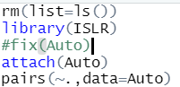

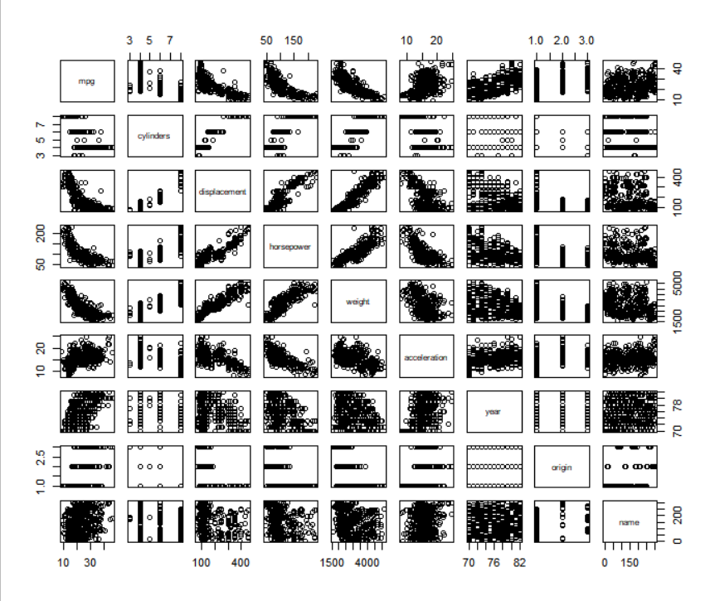

(b)



We have excluded the variable “name”, which is qualitative.

The correlation matrix is shown below,

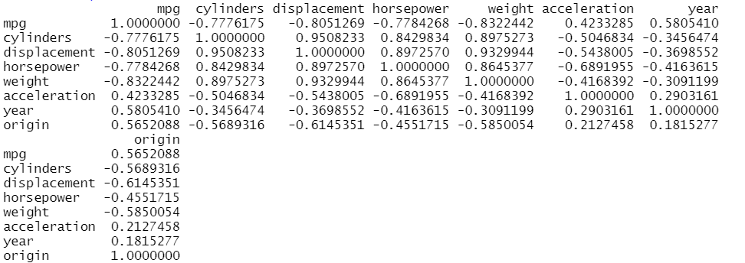

(c)

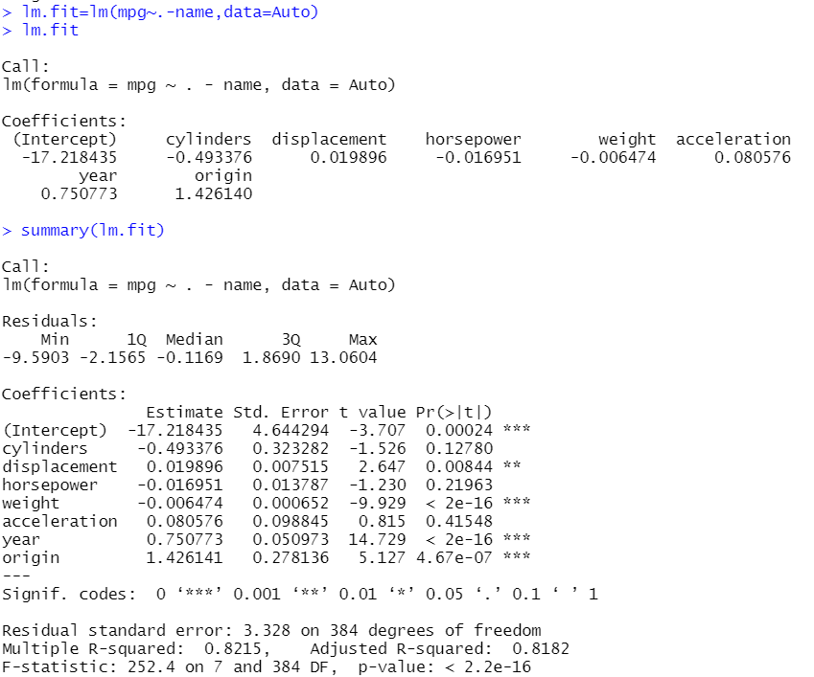

p-value < 0.05 for a F-statistic of 252.4. This shows significant evidence of a relationship between the predictors and the mpg.

p values for displacement, weight, year and origin are less than 0.05, indicating they have statistically significant relationship with response.

coefficient for year is 0.75, i.e., if model year is increased by one year, mpg increases by 0.75 unit, assuming all other predictors are fixed.

(d)



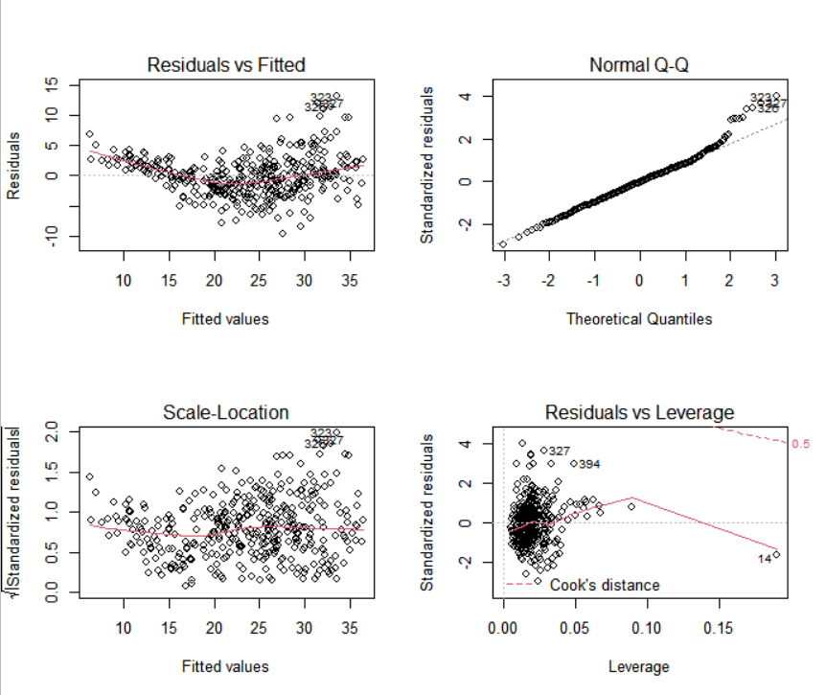

The Residuals v Fitted values chart indicates some non-linearity in the data.



The residuals vs leverage plot shows observation 14, 327, 394 has high leverage value.

The scale-location chart shows some possible outliers. We can confirm by using studentized residuals to find observations with values greater than 3.

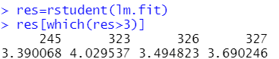

(e)

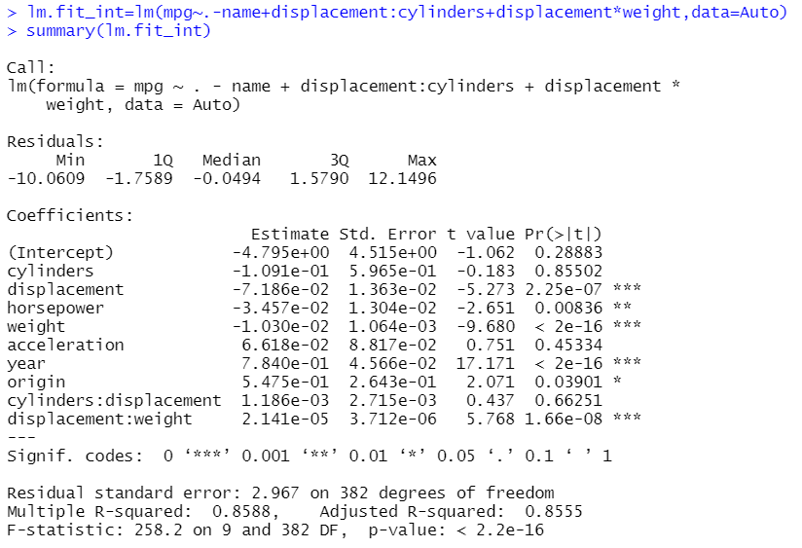

As we include interaction term, we see that R2 value increases to 0.86

(f)

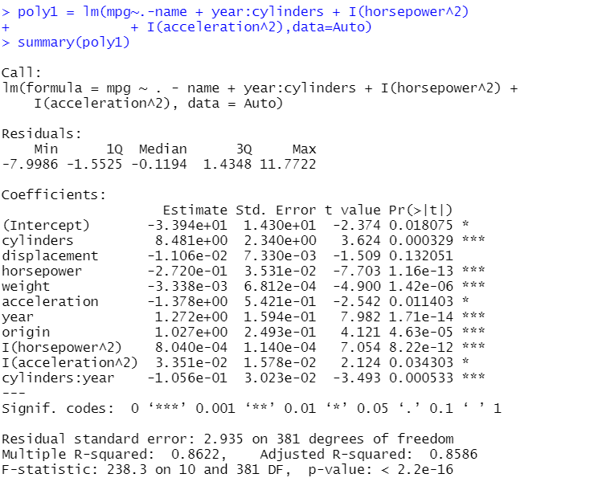

we can see that, all the polynomial terms that we have included are significant.

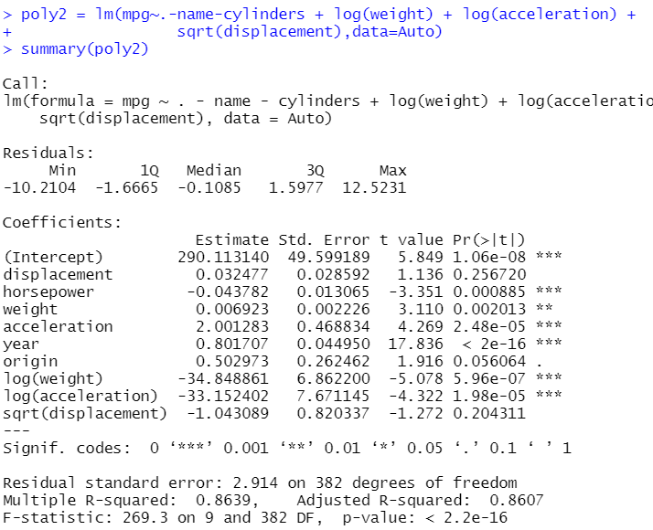

log(weight) and log(acceleration) are significant, but $\sqrt{displacement}$ is not.